WEB422 Assignment 2

Submission Deadline:
Friday, November 11th, 2025 @ 11:59 PM

Assessment Weight:
9% of your final course Grade

Objective:
Build upon Assignment 1 by updating the design / UI, adding detailed "Search" functionality, as well as enabling the user to create a list of their favourite books (currently only saved in memory)
If you require a clean version of Assignment 1 to begin this assignment, please email your professor.

NOTE: Please reference the sample: https://wpas-a2-fall-2025.vercel.app regularly to help you design your components and check your solution. It is there to help supplement the following requirements. This version uses a custom theme called "Cerulean" from https://bootswatch.com. It was added by:

- downloading the theme (bootstrap.min.css) from https://bootswatch.com
- placing it in the "public/styles/" directory
- Replacing import 'bootstrap/dist/css/bootstrap.min.css'; with
import '@/styles/bootstrap.min.css'; in your _app.js file

Part 1: Adding Search Functionality

The first piece of functionality that we will add to our assignment is to allow users to search for books from the openlibrary.org books API

- Begin by re-naming your index.js to books.js (do not forget to re-name the name of your component from "Home" to "Books"
- Create a new index.js file with a barebones "Home" component that renders the text "Search"
- Remove the "Books" link from the "MainNav" component
- Add the attributes as={Link} and href="/" to the <Navbar.Brand> element in the "MainNav" component

Before we add any search functionality, we should add update our "PageHeader" component so that it's more dominant on the page, as well as accepting an optional "subtext" parameter:

- Begin by updating "PageHeader" to accept a 'subtext' property.
- If desired, you may start fresh and use new HTML / components for the header (this was done in the example)
- Ensure that you only render the 'subtext' value / element if it was passed to the component by props (ie: isn't falsey)
With our new PageHeader in place, we should add it to our index.js with some custom text / subtext, ie:
<PageHeader text='…' subtext='…' />

Beneath our new header, we will create our new "Search" form:

- This form will be using 'react-hook-form', so install it now using "npm i react-hook-form"

- Next, we must create the form itself. If you like, you may use the following <Form> code: (available here) as a starting point.
NOTE: ensure that the form fields are named using the following values (this is important, as these will be mapped to search parameters for the search on openlibrary.org)

  - author
  - title
  - subject
  - language
  - first_publish_year

- When the form is submitted, we will use the router (from the useRouter() hook) to navigate to the "books" path, using the following code (assuming "data" is the form data in your handle submit function):
router.push({
pathname: '/books',
query: Object.fromEntries(Object.entries(data).filter(([key, value]) => value !== ''))
});

Essentially, what is happening here is that we're instructing Next.js to redirect us to the "/books" path, but with an additional query parameter, built from the form data. However, it will also omit any key/value pairs where the value is an empty string (ie: the user didn't enter any values in the form).
For example, if the user entered only "Douglas" for author, "Galaxy" for title, and "1979" for first_publish_year, the query string would be: ?author=Douglas&title=Galaxy&first_publish_year=1979

- Finally, you must ensure that the user enters a value for author (it is "required"). If "author" is missing, be sure to:
  - Show an appropriate error message beneath the form field
  - Highlight the form field (by adding the class "is-invalid")
  - Prevent the form submitting if there are any errors

Please review the notes on Form Validation for detailed instructions.

Part 2: Showing Search Results

Once a search is executed from the home page (index.js), the user will be redirected to the "Books" component (books.js) with a complete query string that can be used in the search for books.
Currently, this component only shows books by a single author. This is achieved by using the following code to fetch the data using SWR (from the Assignment 1 example):
const { data, error } = useSWR(`https://openlibrary.org/search.json?author=${encodeURIComponent('Terry Pratchett')}&page=${page}&limit=10`);

However, since we now have the query string, we can construct a full query (instead of just "author") by using the following code:
const queryString = new URLSearchParams(router.query).toString();

The above code will the current page's URL query parameters (accessible via "router.query") and serializing them into a standard query string that can be used in our code to fetch the data. This means that we can update the above useSWR code to use the new query:
const { data, error } = useSWR(`https://openlibrary.org/search.json?${queryString}&page=${page}&limit=10`);

Once this is complete, you should see the search results appear in your table!

The final step should be to update the <PageHeader /> component, since at the moment it is hard-coded to show something like: "Novels by Terry Pratchett" (from the Assignment 1 example). To achieve this:

- Set the main text (ie: the "text" prop) to something like "Search Results"
- Set the subtext (ie: the "subtext" prop) to show what the query parameters were for the search (for example: see the following search using the sample solution).
HINT: If you want to loop through all query parameters and get the key, value pairs you can use something like this (however, consider using .map() for your solution):
Object.keys(router.query).forEach(key=>{
console.log(`parameter: ${key} - value: ${router.query[key]}`);
})

Part 3: Saving Favourite Books (part 1)

Quick Note: Before you do anything else, make sure to add a link to "/favourites" in your MainNav component. Since we are not persisting the favourites (only storing them in memory), this will be your only way to test the functionality.

For this assignment, we would like users to be able to add specific book to a "favourites" list. This will involve:

- Installing jotai from npm, (ie: npm i jotai)
- Creating a store.js file in the root of your application (ie: "my-app/store.js")
- Using Jotai to create a "favouritesAtom" with the default value of [] (an empty array), defined within the store.js file

With our "atom" in place, we must now update our "BookDetails" component (/components/BookDetails.js) to use it, and provide a mechanism (button) to allow the user to specify a book as one of their "favourites" and add it to the list.

However, before we begin, we need to support two additional props: workId and showFavouriteBtn (Note: the default value of the showFavouriteBtn prop should be true). Once this is complete, update your solution to use the new props, ie:
- File: /pages/works/[workId.js]
Should use: <BookDetails book={data} workId={workId} />
Where workId is the is the value from router.query
- File: /pages/about
Should use: <BookDetails book={book} workId={...} showFavouriteBtn={false} />
Where … is your hard-coded book's workId

With this refactor complete, we can now update the code in our "BookDetails" component, primarily:
- import both the "useAtom" hook, and the "favouritesAtom"
- import the "useState" hook

With the imports in place, we can now focus on the additional logic required for this component, specifically:
- Get a reference to the "favouritesList" from the "favouritesAtom" (HINT: this can be done using the "useAtom" hook)
- Add a "showAdded" value to the state (this will control how the button (defined below) is displayed) with a default value of true if the "favouritesList" includes the workId and false if it does not
- Add a "favouritesClicked" function (to be invoked when the button (defined below) is clicked), according to the following specification:
  - If the "showAdded" value in the state is true, then we must remove the workId from the "favouritesList" (effectively removing this book from the favourites list). This can be done using the code:
setFavouritesList(current => current.filter(fav => fav != workId));
(assuming that you have defined the function "setFavouritesList" when using the "useAtom" hook with the "favouritesAtom")
We must also set the "showAdded" value in the state to false (since the artwork is no longer in the favourites list)
  - If the "showAdded" value in the state is false, then we must add the workId to the "favouritesList" (effectively adding this book to the favourites list). This can be done using the code:
setFavouritesList(current => [...current, workId]);
(assuming that you have defined the function "setFavouritesList" when using the "useAtom" hook with the "favouritesAtom")
We must also set the "showAdded" value in the state to true (since the book is now in the favourites list)
- If the showFavouritesBtn prop is true, Add a <Button> Element at the end of your <Col lg="8"> element (ie: below the book links) according to the following:
  - Has a "variant" attribute set to "primary" if the "showAdded" value in the state is true, or "outline-primary" if the "showAdded" value in the state is false
  - When the button is "Clicked" invoke the "favouritesClicked" function (defined above)
  - Shows the text "+ Favourite (added)" if the "showAdded" value in the state is set to true, or just
"+ Favourite" if the "showAdded value in the state is set to false

Part 3: Saving Favourite Books (part 2)

If you test the UI now, you will see that you can toggle the "+ Favourite" button for an individual book to add / remove it as a "favourite". However, there doesn't exist a page for us to view all of the favourites added. To remedy this, we must add a "Favourites" component in the "pages" directory using file name (favourites.js), such that:

- It gets a reference to the "favouritesList" from the "favouritesAtom" (HINT: this can be done using the "useAtom" hook)

- If favouritesList has any items in it (ie: the array is not empty), it:

  - Shows a <PageHeader /> component with relevant text and subtext properties, ie: "Favourites", "Your Favourite Books", etc.
  - Shows a <Row className="gy-4">…</Row> element that renders a single <Col lg={3} md={6}> <BookCard workId={workId} /></Col> element for every item in the favourites array (where workId is a value from the favouritesArray.
Important Note: We will create the <BookCard /> Component in "Saving Favourite Books (part 3)". In the meantime, if you wish to test this, you can simply output <Col lg={3} md={6}>{workId}</Col> for every element in the favourites array. Do not forget to add the correct key property where appropriate

- If favouitesList does not have any items in it (ie: the array is empty), it:
  - Shows a <PageHeader /> component with relevant text and subtext properties, ie: "Nothing Here", "Add a book", etc.

- Important Note: Pagination is not required for this component

Part 3: Saving Favourite Books (part 3)

To properly render the Favourites page, we will need to add another component: "BookCard" within our "components" folder, ie: (/components/BookCard.js) according to the following specification:
- It must accept a single prop: workId
- It will use SWR to fetch the book information using the workId prop, ie:
useSWR(`https://openlibrary.org/works/${workId}.json`);
- If there was an error fetching the book information, or no data was returned it should render an error using <Error statusCode={404} /> (from "next/error")
- If data was returned and there was no error, it should render a single <Card> component containing the following child components / data:
  - <Card.Img variant="top" /> with the exact same "onError", "className", "src", and "alt" properties as your <img /> component in BookDetails. The only difference is that we will use the -M.jpg url instead of -L.jpg, since this image will be smaller.

  - <Card.Body> containing:

    - <Card.Title>…</Card.Title> Containing the book's title or "" if there is no title
    - <Card.Text>…</Card.Text> Containing the book's first_published_date or "N/A" if there is no first_published_date.
    - A Link or Button with an href value of `/works/${workId}` where, workId is the value of the workId prop passed to the component

Assignment Submission:
- Add the following declaration at the top of your server.js file:
/********************************************************************************
* WEB422 – Assignment 02
*
* I declare that this assignment is my own work in accordance with Seneca's
* Academic Integrity Policy:
*
* https://www.senecapolytechnic.ca/about/policies/academic-integrity-policy.html
*
* Name: ______________________ Student ID: ______________ Date: ______________
*
* Published URL: ___________________________________________________________
*
********************************************************************************/
- Compress (.zip) your assignment folder and submit the .zip file to My.Seneca under
Assignments -> Assignment 2

Important Note:
- NO LATE SUBMISSIONS for assignments. Late assignment submissions will not be accepted and will receive a grade of zero (0).
- Submitted assignments must run locally, ie: start up errors causing the assignment/app to fail on startup will result in a grade of z  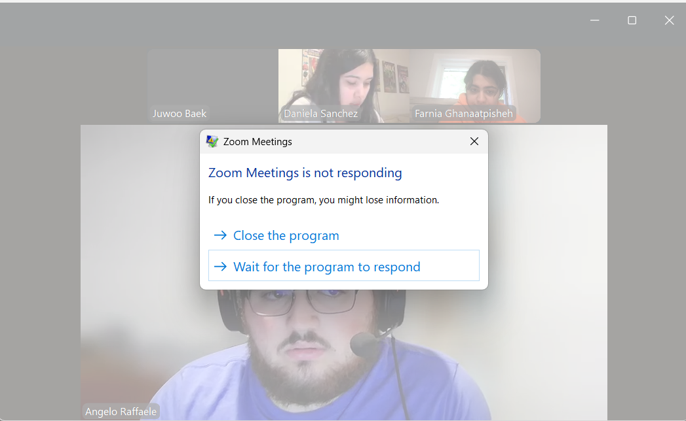ero (0) for the assignment.

